**Class:** Third Year (Computer Science and Engineering)

**Year:** 2020-21 **Semester:** 2

**Course:** Advanced Web and Mobile Application Development Lab (4CS381)

**LA4/ESE Exam**

**14/06/2021 01.00 PM – 04.00 PM**

**Exam Seat No:2018BTECS00044**

Name:Aniruddha Sanjay Palekar

Exam Seat Number: 2018btecs00044

**Problem Statement 1**

**Statement:**

**Design and build a simple weather forecast website using Node.js, Express.js and any database. Add maps.**

**1. Use POST and GET methods appropriately.**

**2. Use different routes for redirection and multiple callback functions.**

**3. Use database connectivity for data storage and retrieval**

**4. Create a page for contact details.**

**5. Select HTML, CSS, JavaScript and other frameworks as per need.**

**Screenshots:**

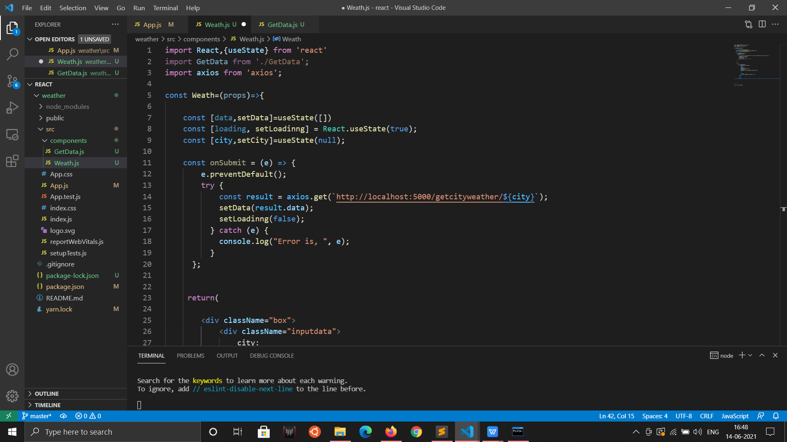

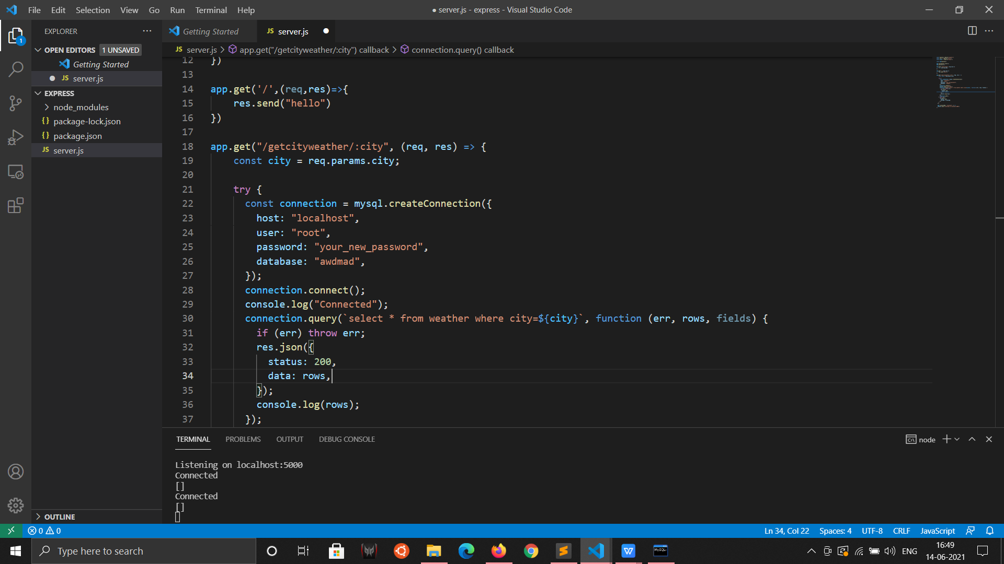

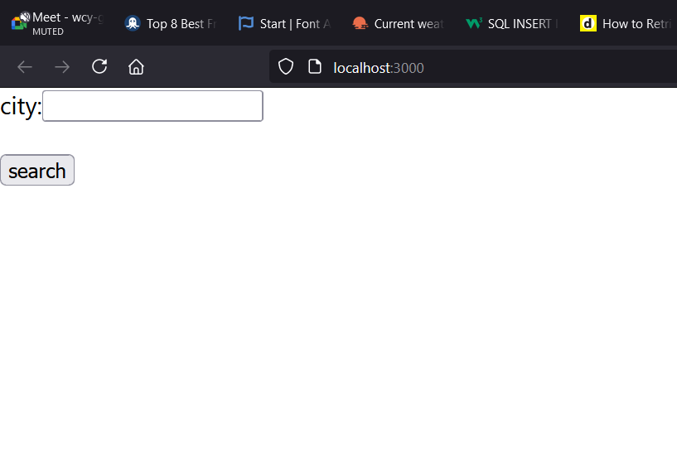

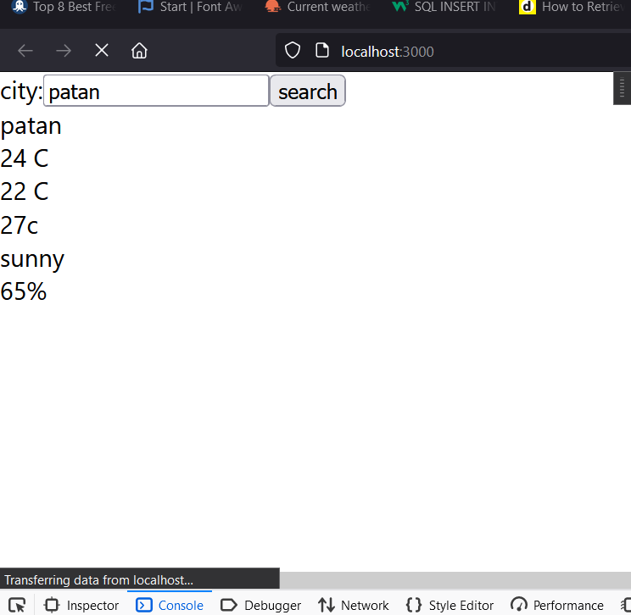

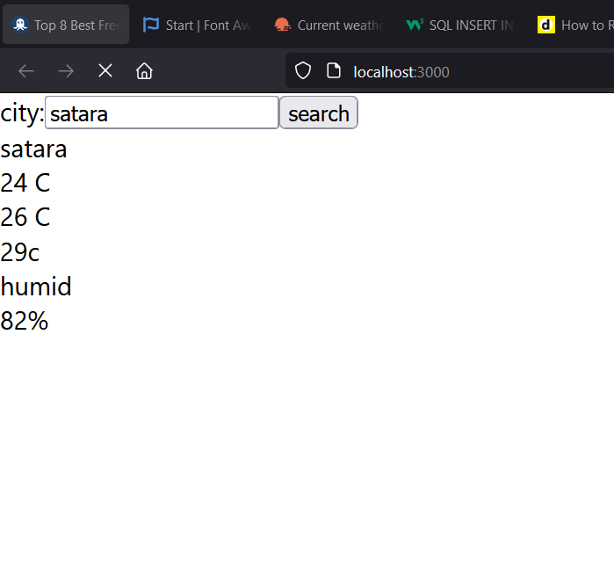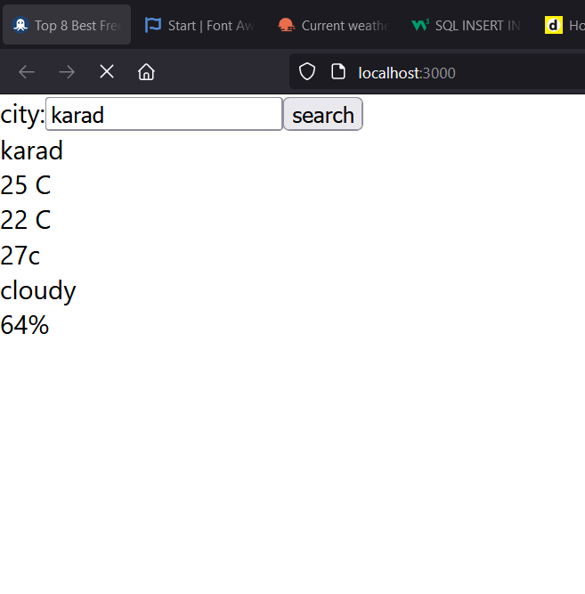

**Problem Statement 2**

**Statement:**

**Create and run React App for weather precautions using different components, props and user defined components.**

**Technologies Used:express,react,mysql**

**GitHub Link:https://github.com/aniruddhapalekar/AWDMAD**